
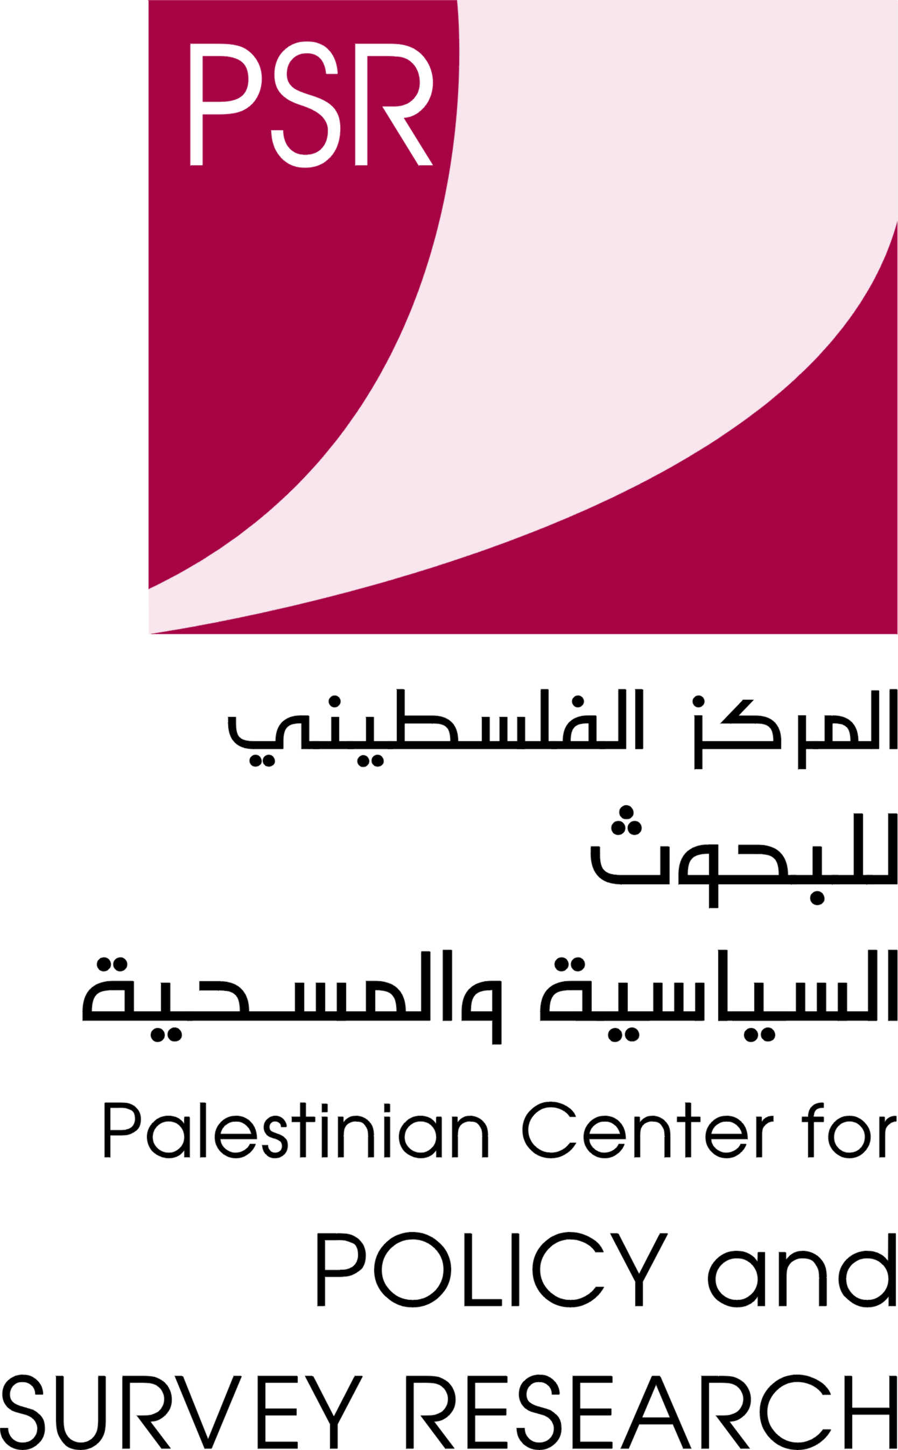
האוניברסיטה העברית ירושלים
המכון למחקר ע"ש הרי ס. טרומן
למען קידום השלום
The Hebrew University of Jerusalem
The Harry S. Truman
Research Institute
For the Advancement of Peace
02-5828076 פקס: 02-5882300/1 טל':
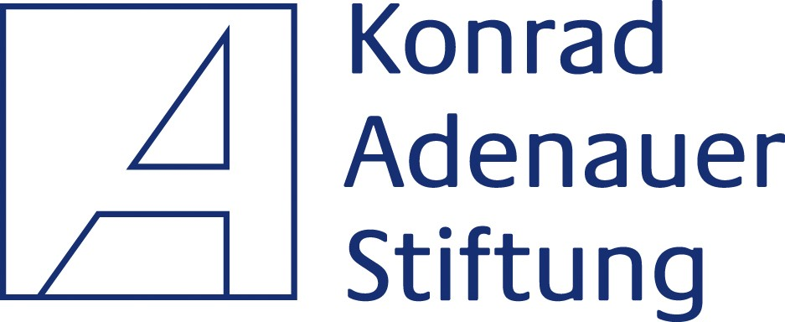

Ford Foundation

October 2010
PRESS RELEASE

Joint Israeli Palestinian Poll, October 2010

PALESTINIANS BELIEVE THEY ARE OF GREATER NEED OF SUCCESS IN THE NEGOTIATIONS, ISRAELIS THINK BOTH SIDES NEED IT EQUALLY, BUT BOTH PUBLICS ARE SKEPTICAL ABOUT THEIR SUCCESS

These are the results of the most recent poll conducted jointly by the Harry S. Truman Research Institute for the Advancement of Peace at the Hebrew University of Jerusalem and the Palestinian Center for Policy and Survey Research in Ramallah, between September 30 to October 7. This joint survey was conducted with the support of the Ford Foundation Cairo office and the Konrad Adenauer Stiftung in Jerusalem and Ramallah.

64% of the Palestinians believe that they and not Israel are of greater need of success in the direct negotiations; 51% among Israelis believe that both sides are of equal need of success. Nevertheless both publics are skeptical about the success of the talks, Israelis overwhelmingly support their continuation while Palestinians oppose it.
If the direct talks fail, the option endorsed by most Palestinians is to ask the UN Security Council to recognize a Palestinian State. The second most popular option is to declare unilaterally the establishment of a Palestinian state. The options to resort to resistance are less popular. However Israelis misperceive these preferences, and fear that Palestinians will resume the Intifada.

The Palestinian sample size was 1270 adults interviewed face-to-face in the West Bank, East Jerusalem and Gaza Strip in 127 randomly selected locations between September 30 and October 2, 2010. The margin of error is 3%. The Israeli sample includes 610 adult Israelis interviewed by phone in Hebrew Arabic or Russian between October 3 and 7, 2010. The margin of error is 4%. The poll was planned and supervised by Prof. Yaacov Shamir, the Harry S. Truman Research Institute for the Advancement of Peace and the Department of Communication and Journalism at the Hebrew University, and Prof. Khalil Shikaki, Director of the Palestinian Center for Policy and Survey Research (PSR).

For further details on the Palestinian survey contact PSR director, Prof. Khalil Shikaki or Walid Ladadweh, at tel. 02-2964933 or email pcpsr@pcpsr.org. On the Israeli survey, contact Prof Yaacov Shamir at tel. 03-6419429 or email jshamir@mscc.huji.ac.il.

MAIN FINDINGS

(A) Palestinian Israeli talks

- Regarding the construction freeze in the settlements 29% of the Israelis support a full construction freeze in all settlements 36% support construction only in settlement blocks which will remain under Israeli rule in a future agreement and 28% support unlimited construction in all settlements.
- Now after more than a month since the beginning of the direct negotiations 78% of the Israelis support their continuation while only 30% among Palestinians support it.
- Nevertheless 64% of the Palestinians believe that they and not Israel are of greater need of success in the direct negotiations while 51% among Israelis believe that both sides are of equal need of success.
- Neither Palestinians nor Israelis think that the negotiations will succeed and yield an agreement. Only 6% of the Palestinians and 5% of the Israelis think that there are high or very high chances for that.
- If Palestinians withdraw from the negotiations, 30% of the Israelis suggest that Israel should change its policy which instigated the withdrawal, 23% suggest to leave the problem to the Americans to take care of, 31% believe that Israel should respond by similar threats to Palestinian counterproductive steps.
- If the peace talks fail, the option endorsed by most Palestinians is to ask the UN Security Council to recognize a Palestinian State (69%). The next most popular option (54% support) is to unilaterally declare a Palestinian state. 51% support the option to start a non-violent resistance. The other options asked about received only minority support: 41% support the resumption of the armed Intifada (57% oppose it); 40% support the dissolution of the PA if the talks fail (57% oppose it), and 27% support abandoning the two-state solution and demanding instead a one-state solution (71% oppose it).
- We also asked Israelis’ assessment as to Palestinian preferred response to a failure of the talks. Israelis perceive quite accurately Palestinians’ preferences to act in the international arena, but they misperceive their preferences on resistance. While Palestinians prefer popular non-violent resistance over armed resistance (51% vs. 41%), 63% of the Israelis fear the Palestinians will resume the intifada and only 42% estimate that they will start a non-violent resistance.

(B) The Saudi Plan

- 56% of the Israelis oppose and 33% support the Saudi initiative which calls for Arab recognition of and normalization of relations with Israel after it ends its occupation of Arab territories occupied in 1967 and after the establishment of a Palestinian state. The plan calls for Israeli retreat from all territories occupied in 1967 including Gaza, the West Bank, Jerusalem and the Golan Heights, and the establishment of a Palestinian state. The refugees problem will be resolved through negotiation in a just and agreed upon manner and in accordance with UN resolution 194. In return, all Arab states will recognize Israel and its right to secure borders, will sign peace treaties with her and establish normal diplomatic relations. In our June 2010 poll 59% of the Israelis opposed the plan while 35% supported it. Among Palestinians, 57% support the plan and 39% oppose it; 67% supported it in June and 30% opposed it.
- 35% of the Israelis support yielding to American pressure to accept and implement the Arab (Saudi) Peace Initiative, while 55% oppose it. Among Palestinians 53% accept such pressure while 42% will reject it. In June 2010, 31% of Israelis thought Israel should accept such American pressure and 60% thought it should reject such pressure. Among Palestinians 60% believed they should accept American pressure to adopt and implement the Saudi Plan, 36% said they should reject such pressure.
- As to their assessments of the other side’s response to such pressure: 26% of the Israelis believe Palestinians will reject and 60% think they will accept it, while 53% of the Palestinians think Israel will reject and 40% think it will accept it.

(C) Conflict management and threat perceptions

- 52% of the Israelis support and 44% oppose talks with Hamas if needed to reach a compromise agreement with the Palestinians. In our June 2010 poll, 49% supported and 49% opposed such talks. However 63% think that the majority of the Israeli public opposes such negotiations and only 22% think a majority supports it.
- Neither Palestinians nor Israelis consider it likely that an independent Palestinian State will be established next to the State of Israel in the next five years. Two thirds of the Palestinians and 60% of the Israelis think that chances for the establishment of an independent Palestinian State next to the State of Israel are non-existent or low; 35% of Israelis and 32% of Palestinians believe the chances are medium or high. In June 2010, two thirds in both publics thought that chances for the establishment of an independent Palestinian State next to the State of Israel are non-existent or low.
- In our poll we also examine periodically Israelis’ and Palestinians’ readiness for a mutual recognition of identity as part of a permanent status agreement and after all issues in the conflict are resolved and a Palestinian State is established. Our current poll shows that 64% of the Israelis support and 24% oppose mutual recognition of Israel as the state for the Jewish people and Palestine as the state for the Palestinian people. Among Palestinians, 49% support and 48% oppose this step. In June 2010, 60% of the Israelis supported and 32% opposed this mutual recognition of identity and among the Palestinians support stood at 58% and opposition at 39%.
- Despite the recent return to dialogue between Fateh and Hamas to reach a reconciliation agreement, neither Palestinians nor Israelis believe that unity of Gaza and the West Bank will be resumed soon: only 14% of Palestinians and 6% of Israelis think so. 51% of Palestinians and 29% of Israelis think that unity will be resumed only after a long time. 30% of Palestinians and 47% of Israelis believe that Gaza and the West Bank will stay two separate entities.
- Among Israelis, 54% are worried that they or their family may be harmed by Arabs in their daily life, compared to 58% in our June poll. Among Palestinians 76% (compared to 74% in June) are worried that they or a family member might be hurt by Israel in their daily life or that their land would be confiscated or home demolished.

